Mary Joy Development Association
Annual review 2017
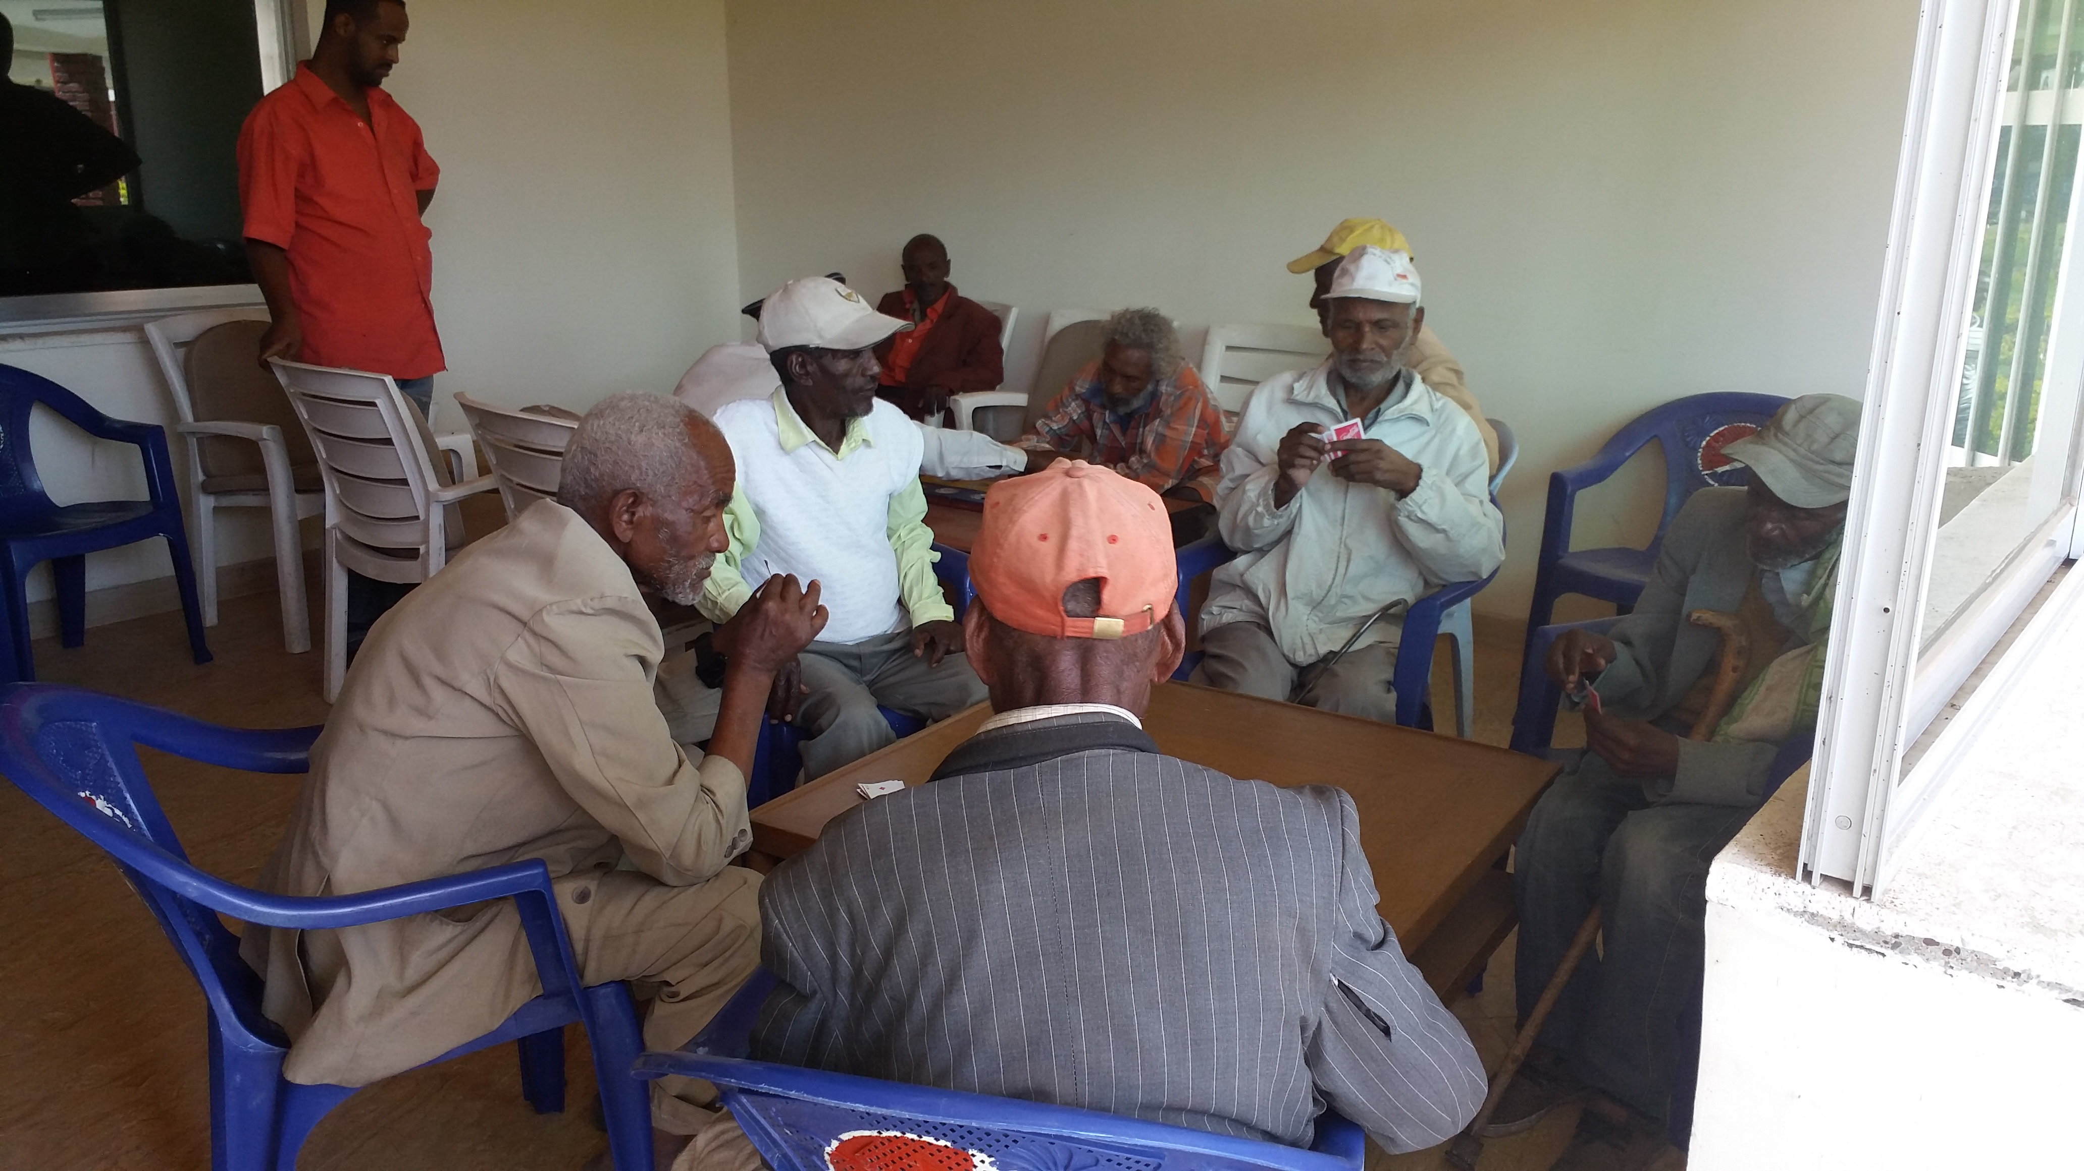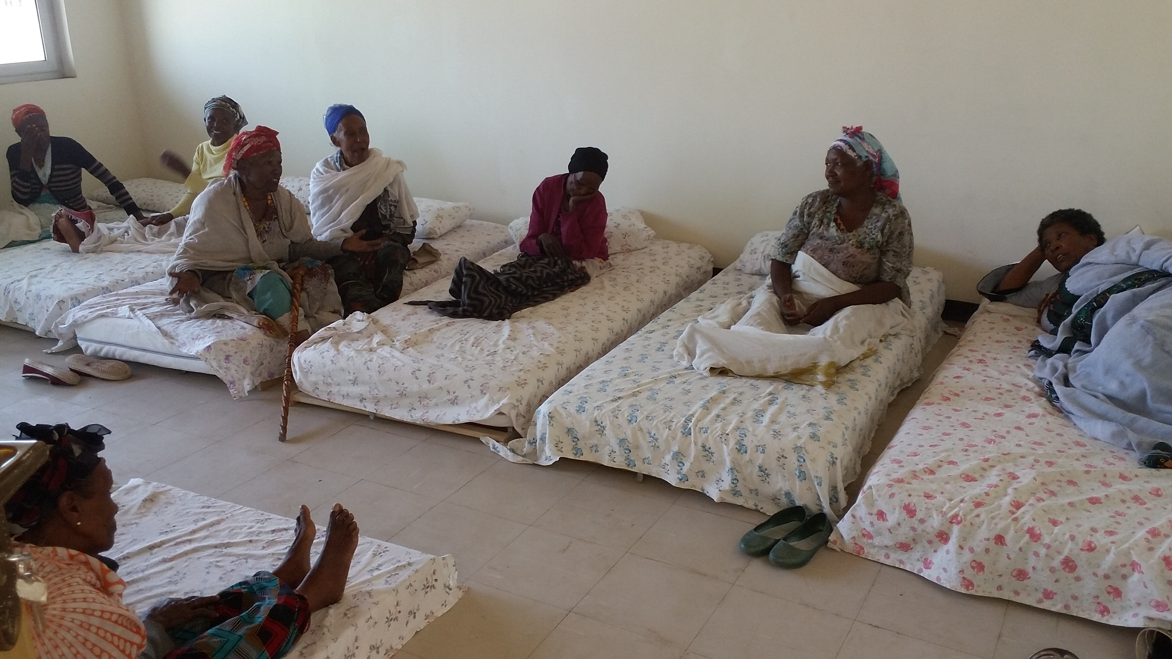
A good youth ought to have a fear of God, to be subject to his parents, to give honor to his elders, to preserve his purity; he ought not to despise humility, but should love forbearance and modesty. All these are an ornament to youthful years. (Saint Ambrose)
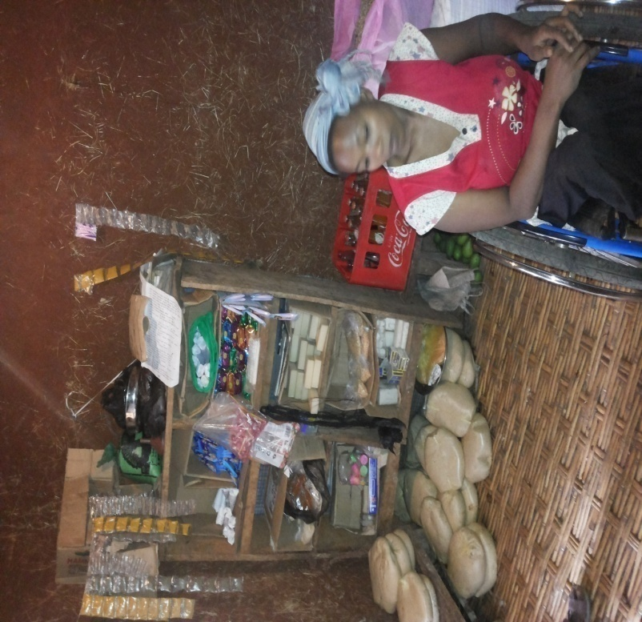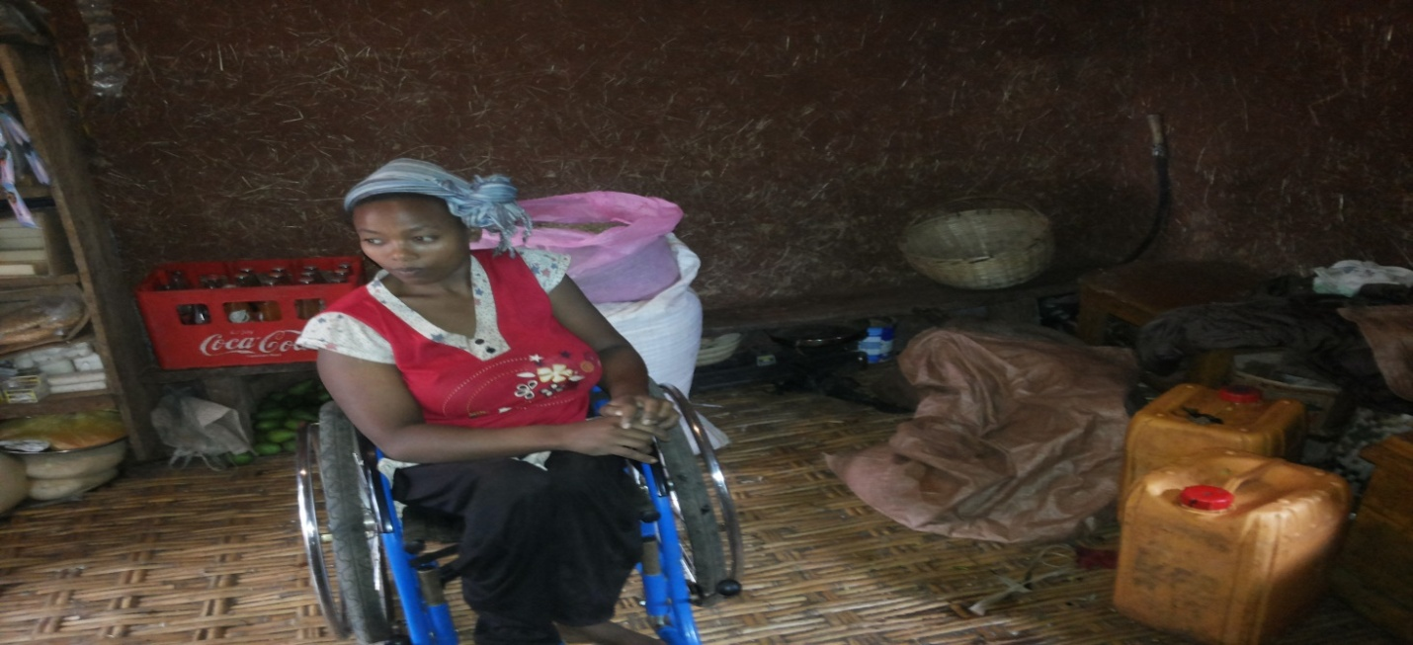
“One thing I learned from this project is importance of saving and disability doesn’t mean incapability. I am success full”
Haymanot Gedicho
25 years
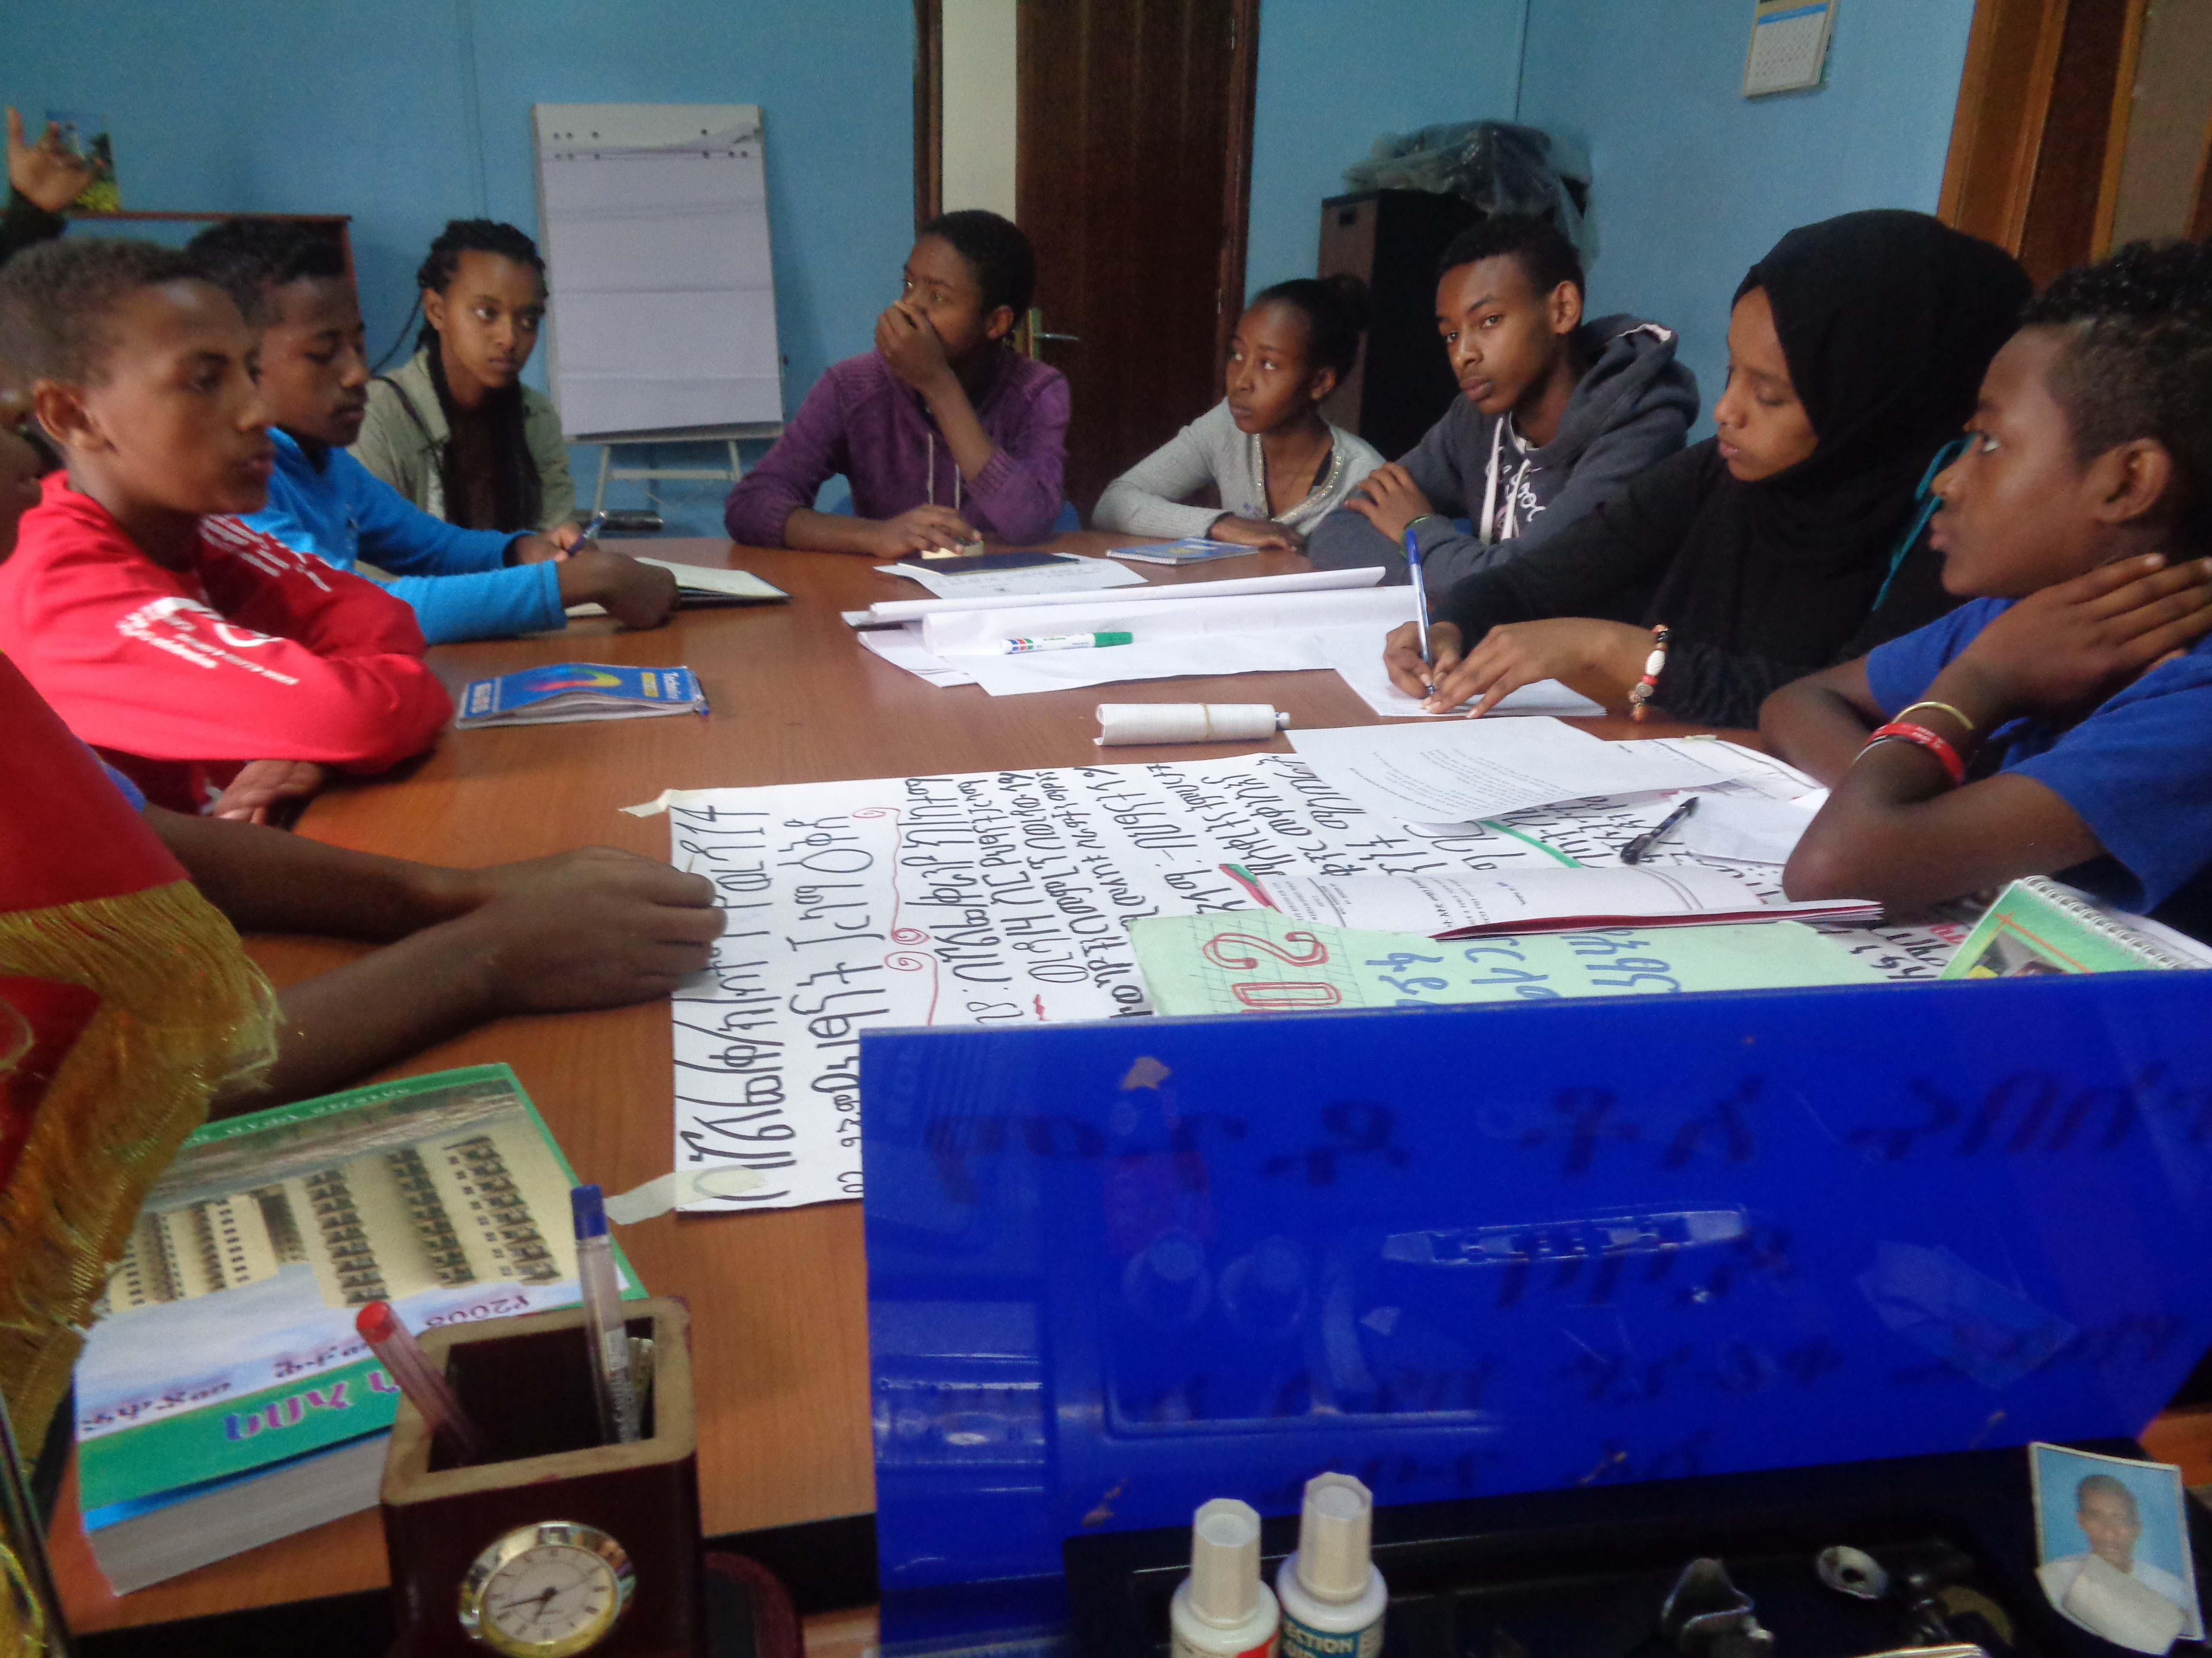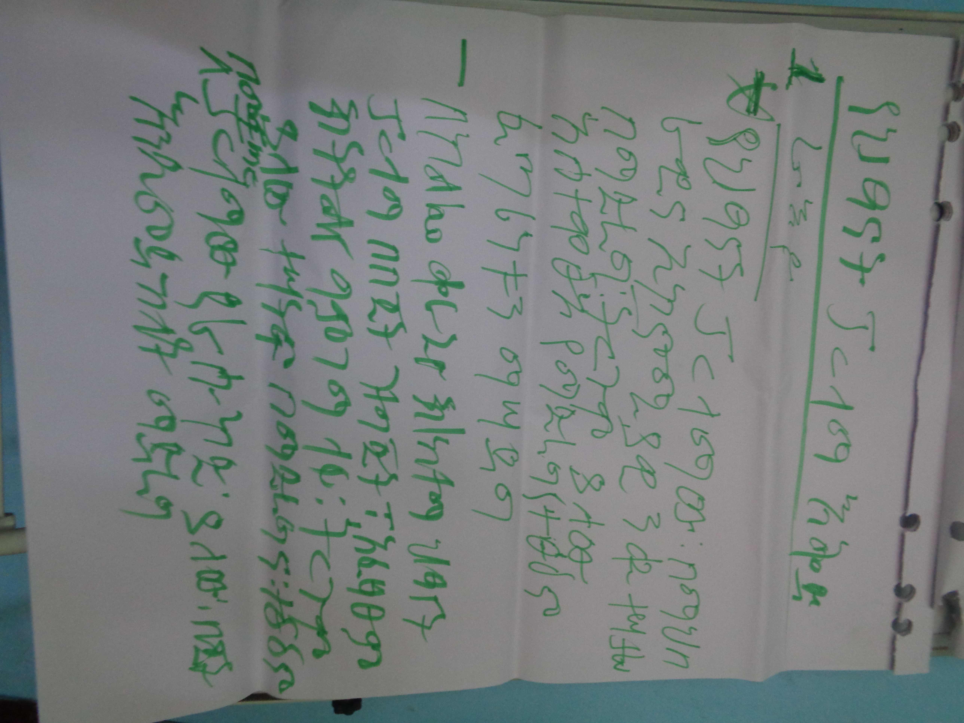
“We are capable enough to contribute to our motherland development as long as you facilitate enabling environment for genuine participation of children in the issues affecting our lives”
Children Parliament
Kolfe Keraniyo Sub city

February 2018
Table of content
Acronym 3
1. Back Ground 4
1.1. WHO WE ARE 4
2.2. WHAT WE DO 4
2.3. Major Goals 4
2.4. WHERE WE WORK 4
2.5. WHOM WE SERVE 5
2. 2017 in perspective 5
2.1 Projects under implementation 5
2.2. Budget Plan 7
3. 2017 Achievements 8
3.1. Education 8
3.2. Health 11
3.3. Economic strengthening 30
3.4. Private-Public-Partnership 37
3.5. Children empowerment and participation 40
4. Challenges 43
5. Appreciation and gratefulness 43

Acronym
ANC Anti-Natal Care
ART Antiretroviral Treatment
ASRH Adolescents Sexual and Reproductive Health
AYSRH Adolescent Youth Sexual reproductive Health
CCC Community Committee Coalition
CSSG Community Self-Saving group
EFCI Ethiopian Female Cancer Initiatives
ETB Ethiopian Birr
FC Female Cancer
GTP Growth and Transformation Plan
HAD Health Development Army
HC Health Center
HEW Health extension Workers
IEC Information Education and Communication
MCH Mother Child Health
ME Micro Enterprise
MJDA Mary Joy Development Association
MOU Memorandum of Understanding
PMTC Prevention Mother to Child
PPP Private-Public- Partnership
PSTA Parent Student Teachers Association
RMNCH/FP Reproductive Maternal Neonate Child Health/Family Planning
SBCC Social Behavioral Change Communication
SDG Sustainable Development Goal
SNNPRS Southern Nation Nationalities Peoples Regional State
TB Tuberculoses
TOT Training of Trainer
VCT Volunteer Counseling and Testing
VIA Visual Inspection with Acetic Acid
WASH Water and Sanitation and Hygiene
YPP Youth Peer Providers

MJDA’S KEY INSPIRING DISCLAIMER
Mary Joy Development Association strives to see a healthy, poverty free and empowered society.

Mary Joy Development Association is an Ethiopian resident charity that works to empower vulnerable and underserved community groups through integrated development programs
Mission
Vision

- Commitment to make a difference in the lives of our target communities through relevant, proactive and value added programming
- Transparency and accountability at all levels to ourselves and to all stakeholders with special attention to our target beneficiaries

Core values

- Integrity/trustworthiness we act with honesty and integrity, not compromising the truth.
- Non-discrimination as all people are equal regardless of their religion, gender, ethnic background and political belief,
- Self-reliance on our own capabilities and resources
- Teamwork: we are supportive of each other’s efforts, loyal to one another, and care for each other both personally and professionally.
- Respect for all, including treating people with dignity and valuing different viewpoints

- Community mobilization, sensitization and Awareness Creation

Core strategies

- Collaboration, Partnership and Networking
- Integrated Programming
- Mainstreaming of cross-cutting issues
- Resource mobilization
- Internal capacity building & physical infrastructure

Key result area

MJDA’s Development Framework

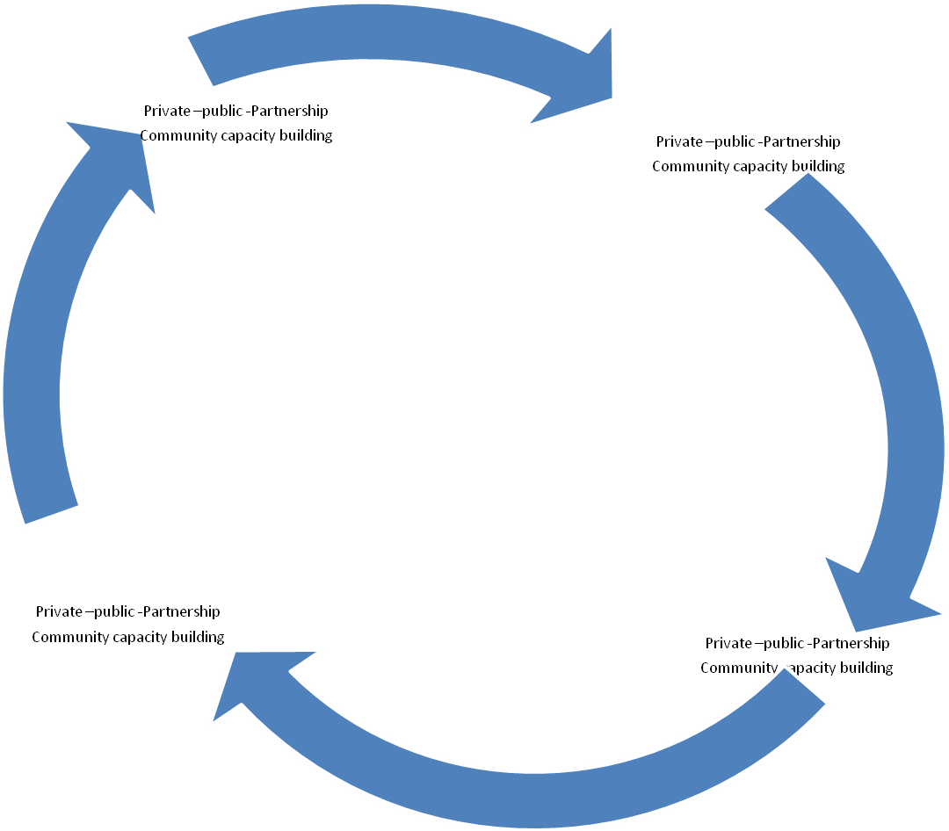
Up-lift target communities living from bellow poverty line
Improved access and completion of pre and primary education for school aged boys and girls
Self-sustained empowered, healthy children and community
Proactive, Responsive, community groups’ private sectors and MJDA created
Ensured child survival and development

Summary

Mary Joy Development Association counts on 24+ years in the development arena. The development and dynamic of the association has shown steady growth. In the period under review, MJDA operates 112 woredas and/or kebeles and 24 small and big towns including Addis Ababa, Hawassa, Bishoftu, Dilla. There were seven international partners who have been working with us in the area of Livelihood enhancement, education and health. The private Public partnership which entirely focus on working with the local partner private sectors, government sectors and individuals in country and diasporas living overseas. Overtime, the Private-Public-Partnership program share is increasing and reached at the level of 36% from ZERO ten years ago. The private Public-Partnership program primarily focuses children and elders sponsorship, Hawassa elder construction and provision of services for elders at the center.
Under education component, there were 11 major activities planned, by which all planned activities are implemented with various performance level 178% and the lowest one is 76%. The reason behind the highest performance is that during the beginning of the Ethiopian academic year there were many school aged children who were seeking of education that our volunteers aggressively work and persuade the schools to exempt children from school development contributions.
Over the years MJDA commits itself on creating facilitative environment for school aged children to accessing formal education, retaining and improving academic performance of targeted children through various supporting mechanisms with the theme of “ no one left behind from education” which MJDA achieved it successfully. As result in the period under review, almost 100% of targeted children promoted to next grade according to the assessment report out of 733 children at Kolfe keraniyo sub city. Only three drop outs and three detained children are registered over the period. In the same scenario, out of the total Yekokeb Brhan program in school targeted children ( Female 6803; Male 6689), 97% promoted to the next grade and 65% with good academic achievements compared to the previous years. Only 2% of children have dropped out and 2% have detained as well. The detained and dropout rate found to be insignificant bellow one-percent out of the targeted children as a result of frequent follow-up by volunteers and awareness of the family on the value of education. Such results have been achieved as a result of the government, private and communities’ strong participation and contributions. Over the year, over 872,000 ETB have been mobilized to cover the educational cost of targeted children.
The health component of MJDA’s interventions more of spiraled on prevention aspects and escalating of the demand side for the services. Indeed, compared to other years, MJDA’s this year health interventions are many that counts on 58 major activities. The performance level is varies with the highest ratio of 194% and lowest ratio is 38%. Out of the total planned activities 64% achievement levels are above 90%. 33% of planned activities range from 80% to 38%. Four activities are re-planned for 2018. Enhancing the demand side for the services such as RMNCH/FP, nutrition, TB, WASH, PMTCT, in the period under review, MJDA has been working with 44 Primary Health Care Units, (PHCUs), 300 health posts and 330 schools grade 1 to 8 so as to addressing 159,373 with the knowledge and information to accessing those services available to in their respective locality. As result, the interventions contributed to improving health service seeking behavior among the community that are reflected by the number of women with skill birth attendants increased, women with the knowledge and utilization of various forms of family planning methods increased, mobilized the community to improve the WASH system of the schools,. Moreover, the interventions enhance the capacity of SBCC structures such as Health Extension Workers, Health Development Army, Women Development Army, in schools clubs and primary health care units.
In the period under review women cervical cancer prevention, care and support interventions were among the health programs interventions with the strategies of TELL-SEE-TREAT and the following achievments have been gained.
In the period under review, what the impressing achievements have been gained are:
- Seven government health center strengthened with cryo- machine and other accessories for undertaking cervical cancer diagnoses and treatment, (TELL-SEE-TREATMENT)
- Under Health and care service component, the following major services provided for HVCs and CGs in the reporting period: Immunization facilitated for 232 HVCs, HIV & AIDS education for 7552 HVCs and 5213 CGs, non-HIV & AIDS education for 7855 HVCs and 5420 CGs, medical expenses for 1597 HVCs and 224 CGs. 838 HVCs and 363 CGs referred for HCT, and one HVC and two care givers confirmed to HIV positive.
- 20,000 community members at malaria prone areas in Gamogofa zone have been sensitized and educated to prevent themselves from Malaria epidemic and mobilized the community to avoid malaria mosquitoes breeding sites and use of bed net utilization.
- 23 health professionals received intensive and very expensive training on the procedures of counseling, SEE and TREATEMNT and REFERAL training, as a result 4154 women have been screened with VIA and nearly 10% are found to be VIA positive with cryo. Twenty-six of them suspected for cancer and referred to hospitals for further treatment.
- 86420 in school community, in school children and wider community with big proportion female population have been reached with FC information, education through mass media, edutainment sessions, coffee ceremony, events, school youth clubs, and school mini-media.
- 7050 women have been supported to undertake breast examination through palpitation
In the period under review, MJDA has implemented various interventions focusing on social and economic empowerment of eligible target groups aiming to up-lifting socio-economically marginalized women, women headed households, OVC care givers, unemployed youth from economic burden so as to contributing poverty reduction. Major interventions were: Organizing of women in to CSSG ( Community Self Saving Groups, training on Financial management, Business development services, household resource management, business management and leadership, experience sharing, linkage with microfinance institutions and provision of startup capital for targeted groups.
The Economic strengthen interventions have brought about significant changes in the lives of care givers and socio-economic marginalized women that have been demonstrated in the improvement of the well being of the family. Some of worth mentioning outcomes are:
- 291 CSSG groups with 7275 members have been engaging in microenterprises. Currently the operators transact over 11 million Birr. The loan repayment rate is reached at the level of 97% which is the great achievements.
- As result, the micro operators build assets, saving cultures enhanced, able to fulfill the basic and development needs their children fulfilled, male partners attitudes have changed, protect themselves from abuse and exploitations, socially empowered, their participation in various community fairs improved, they established social insurance mechanisms to support each others,

1. Back Ground

1.1. WHO WE ARE
Mary Joy Development Association, an Ethiopian Resident Charity, is established in 1994 with the vision of seeing poverty free, empowered and healthy society. The association is not-profit making, pro-poor and partisan to any one regardless of any variables such as religion, ethnicity, gender etc. The association committed to development, believed and worked for socio-economic empowerment of the targeted community.

2.2. WHAT WE DO
MJDA works in five thematic areas
- Livelihood enhancement
- Education
- Health
- Environmental Health and protection
- Private-Public-Partnership
Cross-cutting issues
- Gender and Development
- HIV/AIDS Prevention care and support, ASRH
- Social Protection, Child safeguarding

2.3. Major Goals
- Liberate/up-lift target communities living from bellow poverty line
- Contribute to SDG and GTP II on improving access and completion of pre and primary education for school aged boys and girls by the end sp
- Improve the health wellbeing of the community
- Improve access to potable water
- Promote PPP to sustaining MJDA’s program

2.4. WHERE WE WORK
Addis Ababa
  - Kolfe Keraniyo Sub city [ 15 Woreda]
  - Gulelie Sub city [ 4 Woreda]
  - Yeka Sub city [ 5 Woreda]
  - Bole Sub city [ 2 Woredas]
  - Addis ketema Sub city ( Three Woreda)
  - Kirkos Sub city ( Three Woreda)

SNNPRS
  - Hawassa [ 32 Woredas]
  - Sidama Zone [ Yirgalem, Shebedino, Aleta Wondo ]
  - Gedeo Zone [ Dilla,Yirgachefe]
  - Arbaminch town and Arbaminch zuria woreda Zigity Baqolie Woreda
  - Gamogofa Zone ( Nine woredas-Demba Gofa, Geze Gofa, Ubadebretsehay, Chencha, Kucha, Daramalo, Bonkie, Boreda and Ditta)
  - Wolaita zone (2 woredas, Sodo Zuria and Damote Gale, Kebeles: Delbo wegene, Delbo Atiwaro, Weshegale, Shashe gale)
  - Hadiya zone (2 woredas, Soro and Lemo, Kebeles: Andegna homoshera, Huletegna homoshera, Sadama mardinchu, Andegna selfe, wesheba)
Oromiya
  - Bishoftu town

2.5. WHOM WE SERVE
- Highly vulnerable Children
- Care givers
- Youth population focusing on unemployed youth
- Women in general and Socio-economically poor women
- Socio-economically poor elders
- Schools, Health Facilities, CBOs, FBOs, government structures etc
- The wider community

2. 2017 in perspective

2.1 Projects under implementation
In the period under review, there were seven projects under implementation in 112 Woredas and 24 cities/towns that were benefiting over 1.5 million people. Seven international partners named as:
- PACT/USAID
- FHI360/USAID
- Save the Children International
- Christian Aid
- CORDAID
- JSI
- UNFPA were working in partnership with MJDA
Under Private Public Partnership program two big companies such as STELY RMI and NOH REAL STATE were working sponsorship projects with defined period and budget.
Moreover, 835 private sectors, government offices and individuals are working with MJDA through sponsoring children and elders. The number of members at different level Bronze, Gold, Silver and ordinary adult and student reached to 788 members. In addition, 4500 diversified volunteers includes professionals, community volunteers, artists, media professionals, Addis Ababa University School of social work, government staffs etc were working with MJDA in the area of program development, research, resource mobilization, organizational system building, information technology, community service and implementation of project activities.
In the period under review, MJDA was implementing programs includes investment in children and children participation, socio-economically marginalized women and care givers socio-economic empowerment, access and quality of education services for vulnerable children and for all in school children, prevention and curative health services such as Prevention and treatment of Female cervical cancer (TELL, SEE & TREAT), Adolescent and youth reproductive health, RMNCH/FP, Tuberculosis (TB) prevention, treatment and attrition, Nutrition, WASH, HIV/AIDS and PMTCT, Malaria prevention, curative health services such as OPD, laboratory, ultrasound, X-ray, EPI, pre and post natal services, children and elders sponsorship, volunteer mobilization and promotion, comprehensive services for socio-economically marginalized elders through at Hawassa elder center, ASRH counseling and services, library and ICT services for youth at MJDA’s youth center.
The greatest remarkable achievement in 2017 is the inauguration of Hawassa elder center and services are launched. Currently, per day nearly 60 elder have been getting comprehensive services such cafeteria and restaurant services, medical, massage, cerajim, refreshment, indoor and outdoor games and entertainment facilities, library services, handy craft production, bathroom services and others. The center attracts diversified community members, government officials, academic institutions, business community, Diasporas, celebrities etc that resulted in supporting the center in cash, in kind, technical, professional etc as an increasing trend.

2.2. Budget Plan
MJDA planned 29,663,128 ETB for the implementation of the whole project with 73% program delivery proportion and the rest (27%) for administration as depicted graphically bellow.
MJDA’s proportion of program and administration cost, 2017
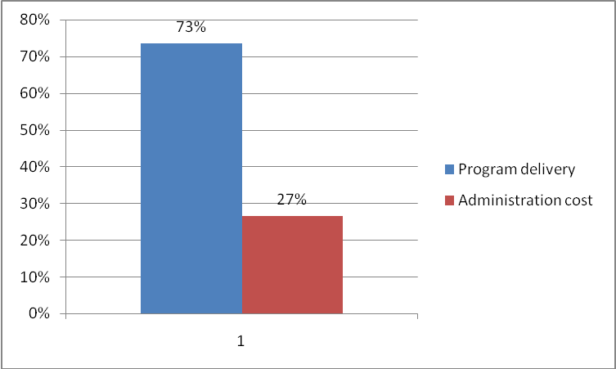

The total budget allocated for program operation is 21,801,439 which are 73% of the total allocated budget. This budget plan was also desegregated by program components as shown in the following pie chart.

MJDA’s budget distribution among program components
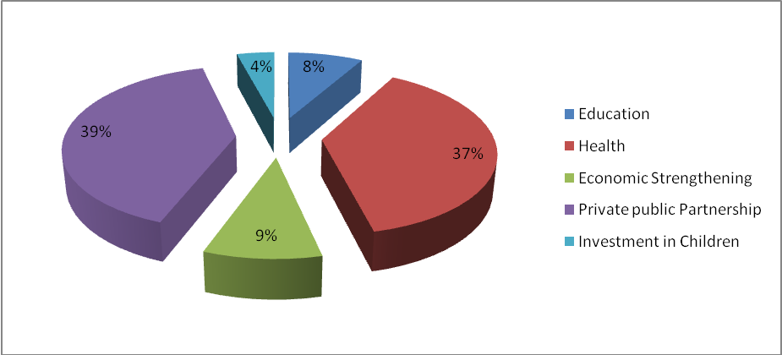

Despite the previous experiences, in 2017 we have seen great deviation on budget distribution among the program component. The grantees strategic shift and interest strongly affects MJDA’s program focus. In the period under review, most of international grant skewed to Health component which is 37%. Having in minded the donors’ resource limitation and strategic shift, MJDA planned to more focus on Private-Public-Partnership which is 39% of the total program delivery. As MJDA’s strategic plan strongly put forth the increasing trend of budget to secure from local resources, the plan from 2014-2018 has been reflecting the decision of various level of MJDA’s governance that would be expected to reach 49% by the end of the strategic plan of MJDA, 2018.

3. 2017 Achievements

3.1. Education

In the period under review, MJDA has implementing capacity building interventions such as teachers training on supporting the government initiatives on quality of education and services for schools, provisions of scholastic materials for Orphan and Vulnerable children, tutorial services, mobilization of schools management and PSTA for school fee exemptions for vulnerable children, strengthen WASH services for in school children, mobilize resources for school feeding for vulnerable children, encourage, support and strengthen school initiatives to emplace systems for children in need of special education, strengthen in schools clubs and mini medias.
Table 1 accomplishment of education program component interventions vis-à-vis plan, 2017, MJDA
No. | Description of interventions | UOM | Annual physical plan | Accomplishment | %age | Remark
1 | Aware and educate caregivers on the value of education through volunteers | No. of person | 11150 | 9750 | 85%
2 | Facilitate and strengthen collaboration with government and private schools for OVC school fee exemption and access to free education | No. of OVC | 1000 | 1781 | 178% | Male 923, Female 858  Covered through community mobilization [ @ the onset the Ethiopian academic year, there were many school aged who were in need of accessing education above the plan wherein the community made extra mile effort to enroll all children to school.
3 | Provision of scholastic materials for 10,000 OVC | No. of OVC | 10,000 | 8734 | 80% | Male 3930; Female 4804; out of these figure 5314 (61%) in school children have got scholastic material support through community mobilization. Resource limitation could not allow us to go beyond.
4 | Provision of school uniform for highly destitute OVC | No. of OVC | 3000 | 2287 | 76% | Male 1029, Female 1258; Out of these figure 1867 children addressed with community mobilization. The resource limitation could not allow us to go beyond.
5 | Provide 2 days training for PSTA members on management, and monitoring skill of quality education in the target sites | No. person | 125 | 145 | 116%
6 | Facilitate after school study support and homework assistant to OVC (for under grade 3 student) by the volunteers | No. of OVC | 7000 | 7322 | 105% | Female 4393; Male 2929  Addressed through community mobilization and volunteers
7 | Closely support volunteers and CCCs to periodically collected information related to enrolment ,retention, progression and reporting | No. of person | 446 | 446 | 100%
8 | Support and strengthen schools on WASH, Nutrition, prevention of Malaria, AYSRH, HIV/AIDS prevention, etc | No. of schools | 50 | 45 | 90%
9 | Facilitate and mobilize resources for school feeding for Vulnerable Children | No. of OVC | 250 | 237 | 95% | Male 149; Female 88  Through community mobilization
10 | Tutorial class support | No. of OVC | 300 | 282 | 94% | Female 180; Male 102 through mobilizing university students
11 | School fee exemption for OVC | No. of OVC | 3750 | 3515 | 94% | Male 1722; Female 1793

In the period under review, the targeted children academic performance have shown progress that is witnessed by almost 100% of targeted children promoted to next grade according to the assessment report out of 733 children at Kolfe keraniyo sub city. Only three drop outs and three detained children are registered over the period. In the same scenario, out of the total Yekokeb Brhan program in school targeted children ( Female 6803; Male 6689), 97% promoted to the next grade and 65% with good academic achievements compared to the previous years. Only 2% of children have dropped out and 2% have detained as well. The detained and dropout rate found to be insignificant bellow one-percent out of the targeted children as a result of frequent follow-up by volunteers and awareness of the family on the value of education. Moreover, the Economic Strengthen intervention librated many of care givers that enable them to cover the costs associated with their children education and also coordination of care efforts have brought about significant contributions in achieving these results. Such results have been achieved as a result of the government, private and communities’ strong participation and contributions. Over the year, over 872,000 ETB have been mobilized to cover the educational cost of targeted children.

3.2. Health
In the period under review, the health component interventions highly weighed up compared to the previous years mainly because of the government and donor groups provided great attentions as a result of the high burden of the health problem of the community and also low utilization of available health services at the government health centers. In relation to this, MJDA has implemented various preventive and curative projects such as Ethiopian Female Cancer Initiatives which is part of the larger national program that dealt with TELL-SEE-TREAT within 11 minutes in case of women having the precancerous lesions, if not three minutes one window, very effective and service user friendly services, social behavioral communications for health that intervene enhancement/build the capacity of health facilities and health information systems, demand increasing on RMNCH/FP, Nutrition, Tuberculosis, Malaria, PMTCT and HIV/AIDS and WASH, ASYRH and curative services under MJDA’s two medical centers and health education campaign for the larger communities.

Table 1 accomplishment of health program component interventions vis-à-vis plan, 2017, MJDA
No. | Description of interventions | UOM | Annual physical plan | Accomplishment | %age | Remark
- 1 | Cover emergency medical expense (like transport, drugs, examination costs) for HVC on credit basis through referral linkage with health institutions | Person | 200 | 103 | 52% | Female 73; Male; 30  98 OVC addressed by the community through community referral linkage. The performance is below the plan mainly because the numbers of service seeker were not as planned.
- 3 | Create linkages with WFP and other food support providers and link children and their caregivers to access these services to improve their nutritional status | person | 1000 | 918 | 92% | Female 532; Male 386
- 6 | Organize TOT for 175 community conversation facilitators for 5 days on HTP and socio cultural barriers in all the project target areas (25 community facilitators from each target town) | person | 100 | 70 | 70% | Female 49; Male 21 The physical performance is below expectations mainly because there were frequent meetings that disturb our plan repeatedly.
- 7 | Conduct community conversation sessions once per month ( women and men) in target kebele on socio-economic empowerment | Sessions | 100 | 80 | 80% | 2000 men and women participated with 60% of female population at Zigity Baqole Kebele, Arbaminch Zuria Woreda. There were frequent meetings organized by the government that disturb the schedule of community conversations participants.
 | Organize 8 bi-annual project performance review meetings with 70 participants composed of project staffs, volunteers, stakeholders and MJDA;s management on rotational basis. | No of meetings | 2 | 2 | 100% | Female 60; Male 80 participate in the review meetings
 | Provide child health services including EPI for children | Children | 9100 | 12265 | 135% | Female 6494; Male 5763; MJDA has got enough EPI drugs from government freely and addressed more children
 | Provide family planning services for women at child bearing age | Women | 5700 | 2404 | 42% | Resource limitation barred to address more women as expected.
 | Provide health treatment and medication services at health facility | Person | 16200 | 15281 | 94% | Female 10391; Male 4890
 | Provide skilled delivery services for women | Woman | 850 | 473 | 56% | For the time being MJDA’s clinic has stopped providing the services because of standard issues.
 | Organize a day long first year project status updating and mapping exercise workshop for the second and third year with the presence of 85 state and non-state actors stakeholders ( Addis Ababa) | person | 85 |  |  | Postponed for 2018 project implementation period
 | Organize a day long FC project launching workshop at the presence of 160 ( 80 Addis Ababa and 80 Hawassa) state and non-state actors stakeholders at Hawassa and Addis Ababa for the new expanded project areas | person | 80 | 60 | 75% | Male 35; Female 25
 | Train 100 new CC facilitators on skills of CC facilitation on cervical and breast cancer for two days ( 60 for Addis Ababa and 40 for Hawassa) | person | 100 | 91 | 91% | Female 77 and Male 14
 | Cascade the training for 200 women and men with the ratio of 1:40 ( one CC facilitator 40 women and men) Addis Ababa and Hawassa | person | 4000 | 3640 | 91%
 | Re-print leaflets (10,000), Flip charts ( 200) counseling cue cards (500), brochures in Amharic for refilling for Addis Ababa and new for Hawassa | Ls | 10700 | 4100 | 38% | Due to budget delay from donor side
 | Develop, print and distribute 20,000 male friendly leaf lets that bear messages “I am responsible for the protection of my spouse, mother, sister and my daughter against cervical and breast cancer” what about you? The message will be told by one celebrity | No. of leaflet | 20000 |  |  | Postponed for 2018 implementation period
 | Organize mass mobilization session on national and international events such as Women’s day, cancer day, international youth day, Healthy mother’s month ( 4000 People will be expected to reach) | Event | 4 | 4 | 100% | Nearly 5500 community members, in school students, health professionals aware about FC
 | TOT training for 100 Youth ASRH Peer Promoters on ASRH, Female cancer and Breast cancer ( 60 Addis Ababa and 40 for Hawassa) | person | 100 |  |  | Postponed to 2018 project implementation period
 | Train 1500 youth ( 750 for Addis Ababa and 750 for Hawassa) for two days on cervical and breast cancer so as to create influence in their respective families | person | 1500 |  |  | Postponed to 208 project implementation period
 | Strengthen children, youth clubs, drama and song clubs with necessary input so as to disseminate information for the wider public | Ls | 1 | 1 | 100%
 | Organize edutainment sessions every month where large people gathering areas like market place, transport services stations, and the like ( 500 people per session x6 = 3000 people will be reached) | session | 6 | 6 | 100% | 55650 community members with diversified background addressed with the information of FC
 | Organize school based art competition such as poem, drama question and answer competition in 20 schools with the theme of “ Female Cancer prevention, care and support” ( 20,000 young people will be reached) | event | 2 | 2 | 100%
 | Organize awareness raising sessions at night ( Addis Ababa 5 and Hawassa 3) night schools to address 2400 adolescents ( boys and girls) where early sexual debut is very common | session | 20 | 20 | 100% | 2700 students participated in the competition
 | Support and strengthen ASRH clubs at youth centers @ targeted Woredas ( 4) [ Hawassa 2 and Addis Ababa 2) with necessary inputs so as to largely disseminate information and knowledge on cervical and breast cancer to 45,000 adolescent and youth | No of center | 4 | 4 | 100%
 | Organize one day higher level sensitization workshop in partnership with Addis Ababa and SNNPRS Health Bureaus and on the status of Cervical and breast cancers for 80 sub city leaders, religious leaders, targeted woredas leaders, health facility directors ( previous year status update, mapping exercise, knowledge platform, consensus building and way forward for the subsequent year intervention) ( 40 Addis Ababa and 40 Hawassa) | person | 80 |  |  | Re-plan for 2018 project period
 | Organize three days community mobilization skills, service mapping exercise, networking and referral linkage for 100 health extension workers at least 7 person per site ( 70 for Addis Ababa, 30 For Hawassa) | person | 100 | 105 | 105% | Female 84; 21 male participated in the training program
 | Organize two days training for 140 Health Extension Workers ( 80 Addis Ababa 20@ each project site and 60 for Hawassa) on breast cancer and cervical cancer ( for the expanded project site) | person | 140 | 55 | 39% | Due to budget delay from donor side
 | Organize a day long training for 210 health Development Army ( 150 Addis Ababa ,60 Hawassa) on breast and cervical cancer including reproductive health as could play a key role in promoting the acceptability of cervical and breast cancer prevention cervices | person | 210 | 293 | 140% | Male 86; Female 207
 | Organize a day long training for 100 CBOs, opinion leaders, religious, on community mobilization, cervical and breast cancers ( 60 for Addis Ababa and 40 for Hawassa) | person | 100 | 194 | 194% | Male 105; Female 89
 | Identify logistics and infrastructural gaps of existed targeted health centers and fulfill to continuing the VIA procedure | No of HCs | 5 | 5 | 100%
 | Procure 5 heater to keep room temperature for VIA room to protect CO2 from freezing ( learned from the previous year experience) | No | 5 | 5 | 100%
 | Train 14 health professionals ( two from each targeted health centers) on SEE and TREAT | person | 19 | 19 | 100% | Female 18; Male 1
 | Procure 7 Cyo-machine including cryo-equipment accessories and spare parts and deploy for the new targeted Woredas’ health centers | No of Cryo | 7 | 7 | 100% | Distributed to seven government health centers
 | Procure CO2 cylinder for the new targeted health centers ( given the previous experience, we recommended | No | 7 | 7 | 100%
 | Identify logistics gaps of the new targeted health centers and fulfilled with necessary input ( maintenance of water system, VIA materials and equipments such as speculum, sponge forceps, deterejents and other consumables for take off | No of HCs | 7 | 7 | 100%
 | Organize continuous updating session on quarterly base at the targeted health center on rotation basis so as to identify gaps/challenges, taking timely actions, etc ( cost covers refreshment and transportation ) Here trained health professionals and medical directors/representatives | No of HCs | 12 | 12 | 100%
 | Transportation and refreshment cost for Mentoring, supervision, monitoring and evaluation of leading organization on bi-annual basis | No of Visit | 4 | 4 | 100%
 | Purchase of cleaning materials and other related consumables ( Addis Ababa ) | No | 50 | 45 | 90%
 | Transportation back and forth from higher level service providers in case of Addis Ababa, Black lion to MJDA, in case of Hawassa, Hawassa referral hospital to MJDA clinic ( in case of referral Hawassa to Addis Ababa) | Ls | 1 |  |  | On going
 | Assess and identify gaps and re-fill the necessary supply for community based palliative care provisions ( re-filling of palliative care kits) | Ls | 1 |  |  | On going
 | Organize five days training on community based palliative care providers for the new targeted Woredas health centers and Hawassa targeted areas 5 community based care providers per targeted woredas/kebeles ( 50 providers, 25Hawassa, 25 Addis Ababa ) | person | 50 | 25 | 50% | Hawassa postponed the training for 2018 project implementation period
 | Purchase and filling of necessary supplies for Community Based palliative care provisions ( kit with necessary supplies) | Kits | 50 | 25 | 50% | Hawassa postponed the training for 2018 project implementation period
 | Support the community based palliative care providers to organizing bi-monthly meeting in their respective village to share experiences, group cohesiveness, faced challenges and the way they overcome, etc | session | 204 | 100 | 49% | Hawassa postponed the training for 2018 project implementation period
 | Recruit active, key players, outstanding contributors and committed 80 community members from 20 community based structures and organize training for three days on mapping, networking and referral linkage and support them to developing their own village level road map to ensuring sustainability | person | 80 | 75 | 94% | Female 68; Male 7
 | Support community structures to establish and put in place networks among service providing institutions that will be the key role players in providing comprehensive support for female cancer patients and their families ( cost covers transportation and refreshment ) | No of visit | 8 | 6 | 75%
 | Organize AYSRH knowledge fair session at Addis Ababa presenting the performance of school clubs, public health centers, youth centers | person | 100 |  |  | Postponed for 2018 project implementation period
 | Organize familiarization / kick off Workshop and familiarize woreda transformation plan guideline at at two project clusters (Arbamicnh consisting Chencha, Ditta, Boreda and Bonke, Dembagofa cluster consists of Kucha, Daramalo, Demba gofa, geze Gofa and Uba Debretsehay) for 1 day with 140 participants from all woredas composed of SBCC structures local government, CBOs, FBOs, HEWs, HDAs, women focused development groups, , mass based associations, , health sectors and schools | person | 140 | 63 | 45% | Male 43; Female 20
 | Organize a three days training for 450 SBCC structures, community members composed of youth , from nine target weredas in 9 sessions focusing on the six health thematic areas and based on the prioritized issues raised from SM kick off meeting | person | 450 | 450 | 100%
 | Following up the implementation of the action plans developed during the social mobilization kick of workshops and providing technical and SBCC material support as needed | group | 9 | 9 | 100%
 | Support implementation of bi-monthly community conversations sessions to various community and hold discussions, create common understanding on the six health thematic areas over the project period (cost only refreshment) | session | 310 | 250 | 81% | 6250 community members highly participated in the community conversation sessions
 | Support pregnant and lactating women , mothers and fathers having children under five to undertake monthly community dialogue session facilitated by trained HEWs, HDA, HC staffs , health posts, trained peer mother groups. (refreshment cost 100 Birr /session) | session | 60 | 45 | 75% | 1125 pregnant and lactating women participated in the discussion and aware of breast feeding, family planning, nutrition, personal and environmental hygiene, bearing a child at health center with skilled birth attendants
 | Organize 6 events of health, World HIV/AIDS, hand washing , breast feeding , TB, International women’s day, youth day at each target woreda yearly in collaboration with health & education offices, woreda WCA, health institutions and schools through promotion of the six health thematic areas , and dissemination of centralized developed IEC materials so as to reach 159,373 community members | event | 54 | 54 | 100% | Various IEC materials distributed for over 30,622 community members on malaria, nutrition, HIV/AIDS/, PMTCT, personal and environmental hygiene, family health
 | Facilitate two days integrated refresher training (IRT) trainings for 80 HEWs in all targeted woredas as needed | person | 80 | 80 | 100%
 | Strengthen health extension workers and health development army to establish and strengthen sanitation clubs in 50 schools in the target area in collaboration with schools management | club | 15 | 15 | 100%
 | Strengthen 50 School RH, malaria and sanitation clubs, and Anti-AIDS clubs (6 clubs per school) through providing training for 180 club members (20 persons per wereda) for three days on the six health thematic areas | club | 25 | 25 | 100%
 | Promote SBCC interventions in the school community (teachers and students) through supporting clubs in 10 schools in a wereda | club | 60 | 60 | 100%
 | Undertake 22 monthly project activities performance review meetings among staffs, SBCC structures and systems in each target woreda | person | 225 | 220 | 98%
 | Organize 4 bi-annual project performance review meetings with 60 participants composed of project staffs, volunteers, stakeholders and Mary Joy management on rotational basis | meeting | 2 | 2 | 100% | 144 SBCC structures participated on the performance review meeting
 | Organize bi-annual review meetings for among projects staffs at the regional coordination office. | meeting | 1 | 1 | 100% | 16 staff members have participated on the performance review meeting

In the period under review, what the impressing achievements have been gained are:
- Seven government health center strengthened with cryo- machine and other accessories for undertaking cervical cancer diagnoses and treatment, (TELL-SEE-TREATMENT)
- Under Health and care service component, the following major services provided for HVCs and CGs in the reporting period: Immunization facilitated for 232 HVCs, HIV & AIDS education for 7552 HVCs and 5213 CGs, non-HIV & AIDS education for 7855 HVCs and 5420 CGs, medical expenses for 1597 HVCs and 224 CGs. 838 HVCs and 363 CGs referred for HCT, and one HVC and two care givers confirmed to HIV positive.
- 20,000 community members at malaria prone areas in Gamogofa zone have been sensitized and educated to prevent themselves from Malaria epidemic and mobilized the community to avoid malaria mosquitoes breeding sites and use of bed net utilization.
- 23 health professionals received intensive and very expensive training on the procedures of counseling, SEE and TREATEMNT and REFERAL training, as a result 4154 women have been screened with VIA and nearly 10% are found to be VIA positive with cryo. Twenty-six of them suspected for cancer and referred to hospitals for further treatment.
- 86420 in school community, in school children and wider community with big proportion female population have been reached with FC information, education through mass media, edutainment sessions, coffee ceremony, events, school youth clubs, and school mini-media.
- 7050 women have been supported to undertake breast examination through palpitation
Addis Ababa
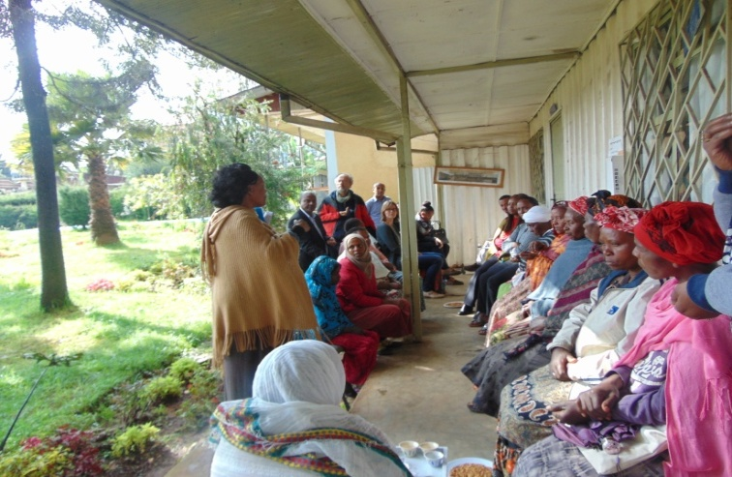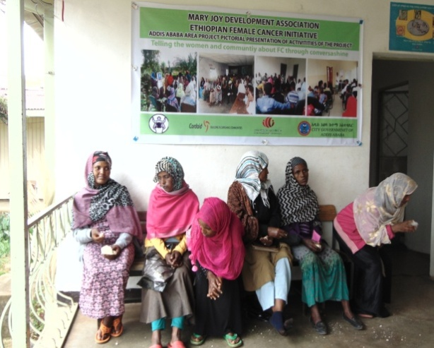
Community conversation through coffee ceremony between the screened and none screened women by providing first hand information for the eligible women can optimize and strengthen female cancer screening service and increase the demand of the community to utilize cervical cancer screening at the targeted health centers. Furthermore the participant of the session can build trust on the program.
As a result of conducting periodical sessions, more than 500 community members were reached and they are expected to cascade the conversation to their neighboring women by conducting coffee ceremony at household level at least for 30 women per session. So that in the targeted woredas and neighboring areas such kinds of movements will increase the interest of the women to utilize the screening service.
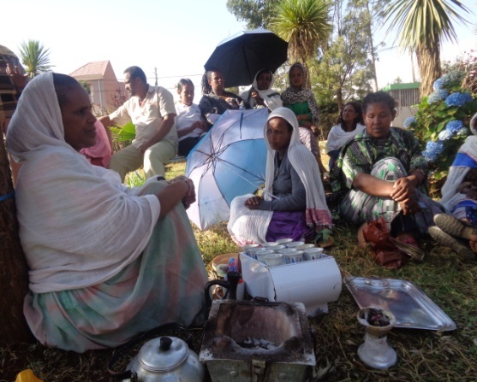

Hawassa
The Ethiopian government has established various community structures that support the health service at the community level; these are the health development army, health extension workers, women development army and other community structures. The structures create good opportunity to reach more and more women individually and in a group to educate, counsel and refer them to health facilities for cervical cancer screening. Hence, working with these community health structures has become very important to increase demand for screening, testing and treatment of cervical cancer services, and they would have value add benefit to screen more women in time and cost effective manner.
The existing communities health structures are working towards bringing health and social change in the community, the structures are organized in a group of 5 and 30 for the purpose of facilitate, control, support and monitor community health including reproductive, maternal and child health activities pertinent to their roles and responsibilities. This implies that the awareness creation, education and training interventions that have been implemented by the project are properly facilitated, controlled, documented, monitored, evaluated and reported.

Case story
My Life was saved due to early screening”
A 43 years old, married, illiterate woman Wro Meseret Negash residing in Yeka sub-city of Addis and mother of 5 children (2 boy and 3 girls) screened for cervical cancer and found to be suspected for ca and confirmed by further investigation that is early stage of cervical cancer and hysterectomy done for her at referral hospital and become well after intervention now she is in a good health status.
When she was asked how she decided to have the screening and from where she heard the information of the screening service she replied, my older daughter encouraging me to have cervical screening near by health center after she was screened and treated for pronouncers lesions herself. Besides she told me that the procedure of screening is so simple, took few minute and advantageous because most women benefited and got better of all symptoms experienced before get relieved from illness. And continuously asking and encouraging me to have the screening by telling me that my long standing back and lower abdominal pain could be due to reproductive health problems. Even though at the beginning hesitated to undergo the screening finally I agreed to be screened she came to the health center with one of her friend for counseling and VIA screening and willing to be interviewed, interested to contribute and work together with Female cancer project in controlling and preventing FC through encouraging women in her neighborhood to get the service, the advantage of early screening and getting treatment without any service charge.

3.3. Economic strengthening
In the period under review, MJDA has implemented various interventions focusing on social and economic empowerment of eligible target groups aiming to up-lifting socio-economically marginalized women, women headed households, OVC care givers, unemployed youth from economic burden so as to contributing poverty reduction. Major interventions were: Organizing of women in to CSSG ( Community Self Saving Groups, training on Financial management, Business development services, household resource management, business management and leadership, experience sharing, linkage with microfinance institutions and provision of startup capital for targeted groups.

Table 3 accomplishment of Economic Strengthening program component interventions vis-à-vis plan, 2017, MJDA
No. | Description of interventions | UOM | Annual physical plan | Accomplishment | %age | Remark
 | Provide two days training for 375 highly vulnerable women on CSSG techniques, procedure, saving, internal loan etc | person | 2240 | 2160 | 96%
 | Print and provision of saving books for CSSG members | person | 2240 | 2160 | 96%
 | Train target community on Parma gardening as the project target area is potentially reach | person | 60 | 60 | 100%
 | Provision of matching input as startup capital for each CSSG groups depending on their saving amount | group | 90 | 84 | 93%
 | Provide business development and management skills training to sponsored children caregivers organized in CSSGs for 3 days | person | 2250 | 2100 | 93%
 | Create and strengthen linkage with the woreda office of small scale micro enterprises to access technical supervision, on job training and professional assistance for target 10 CSSG groups | network | 90 | 84% | 93%
 | Provide five days BDS training for 800 CSSG group members and link to MFI and government employment initiatives | person | 2250 | 2100 | 93%

The Economic strengthen interventions have brought about significant changes in the lives of care givers and socio-economic marginalized women that have been demonstrated in the improvement of the well being of the family. Some of worth mentioning outcomes are:
- 291 CSSG groups with 7275 members have been engaging in microenterprises. Currently the operators transact over 11 million Birr. The loan repayment rate is reached at the level of 97% which is the great achievements.
- As result, the micro operators build assets, saving cultures enhanced, able to fulfill the basic and development needs their children fulfilled, male partners attitudes have changed, protect themselves from abuse and exploitations, socially empowered, their participation in various community fairs improved, they established social insurance mechanisms to support each others,

Success story of W/ro Adanech Kusa
W/ro Adanech Kusa is one of MJDA beneficiaries who live in Weldenakebelle, Dilla town. She lives with her husband and 5 children, 2 female and 3 male.
Before four years, she was leading a life full of economic challenges. She couldn’t able to feed, dress and send her children to school. The family used to live at rent house. All of the household expenditure was covered from the husband’s income. However the money was not sufficient.
It was during this difficult time MJDA project introduced in Dilla town. W/ro Adanech identified as the most venerable family by volunteer. After the kebelle CC approved her status she began to receive different services from the project. After a while her volunteer selected her to take part in economic Intervention program to be a member of CSSG group. After taking five day training she became a member of “LesraEninesa“CSSG group in weldenakebelle.
The group members save 10ETB per week. She took 100 ETB as her first loan. After a while, she then took 1000 ETB and started to sell charcoal and fuel wood in front of her house. As her business increases she took 3000 ETB from her group and bought a cow. At this time her life status improved as her income became stable. She began to feed her children properly, send them to school and house hold expenditure was being covered by her. She bought 4 goats by 5000 ETB she borrowed from the group. After she took her sixth loan, 7000 ETB, she built a two class house which was rented 700 ETB each per month.
Today she covers all the household expenditures by herself. She also has two local “IKUb”,one 150 ETB per week, and 250 ETB per month. She has 6 “Idir”s which she pays 540 ETB per month. She has also a local saving of 40 ETB per month and “kebellekuteba” 120 ETB biweekly.
She has planned to take 10,000 ETB and to open a small scale shop which she believed that will generate a permanent source of income. She said” I am very great full for those who thought me how to save and helped me to change my life.”
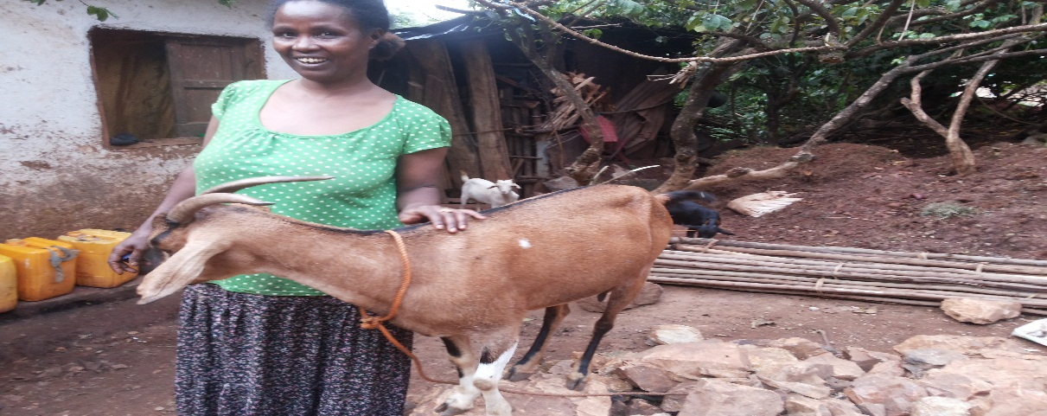
A person having self-esteem wining a challenge, becomes successful.
Exemplary of success
Birtukan Wegaso
W/ro Birtukan Wegaso is 36 years women, lives in Dilla town, Haroke Kebele with her four children. She is one of the target beneficiaries of MJDA, whose life had been filled with untold stories of ups and downs.
Before four years her family was one of the most vulnerable households in the locality. The family livelihood was fully dependent on her husband’s income. However, the amount of finance the husband provides for the household expenses was insignificant to fulfill the basic needs of the family as he had been expensed most of his income for drinking. He was overwhelmed by drunken behavior. As a result of this, her and her family’s life was full of challenges and she was forced to work as a daily laborer to brink a daily bread for her children. Despite the efforts she exerted, the income gained was insufficient to fulfill the basic needs of the family. Due to the difficulty of the job, and psychological challenges she seriously became sick for a long time that made life more difficult, unable to feed, dress and send her children to school.
It was during such a difficult time that MJDA’s project focusing on the support of highly vulnerable children and care givers began to be implemented in Dilla town. The community committee and vulnerable working with the project engaged in the identification of and screening of vulnerable households to be eligible for the program screened her and her family and gets approved by the local kebele administration and the project staffs to be one of the target beneficiaries. Since then she began to get different services from the project. Meanwhile she was also selected to be a member of community self-help group named as “Sertomasaya kuter1” with 17 members in which members initially had been saving 10 ETB on weekly basis that increased to 15 ETB later on and take loan to expand their business. As the other members of the Self Saving Group do, she received 5 days training and after saving for 6 months, she and her group members were supported with a matching fund of 1500 ETB each as a motivation and recognition of their saving to increase their capital important to advance their business activities.

Her saving and the matching fund support became a synergy for her and build up her confidence to start a small scale business. Hence, based on their group’s bylaw, she took the first loan 300 ETB and started a small scale business at her home. She also diversified her business activities by adding selling fire wood and charcoal. She became successful in her business activities and able to return her first loan before the dead line and took her second loan 500 ETB and expanded her business. As she has been successful from time to time, the amount loan she took has increased, and after a while she took 3000 ETB. However she encountered car accident at the day she received this loan. Unfortunately the loan she took had been spent for medication services to save her life. Even though she was sick, she never gave up working her business activities and it was very amazing that she was able to pay the loan on the dead line. Her courage and success at this moment considered her as a model for other members. After a while she took a loan 7000 ETB to open a small scale shop. After she returned her previous loan again she took 10000 ETB. By the loan she began to sell “Enjera and Ambasha” for her neighbors and expanded her shop by adding additional items. As her business diversified she was able to save 700 ETB per week and built house which was rented for 300 ETB per month. During these days her and her family’s life became stable as she has secured source of income she stared to repay loan before the deadline.
Her passion and commitment lifted her up to the better stage of life, which has been reflected by the expansion and diversification of her business in different direction and build her capacity to take a huge amount of loan 15,000 ETB loan and bought a TVS motor bike which generates a daily income of 100 ETB birr per day. At this moment she wants to expand her business and again she took 20,000 ETB and expanded her shop.
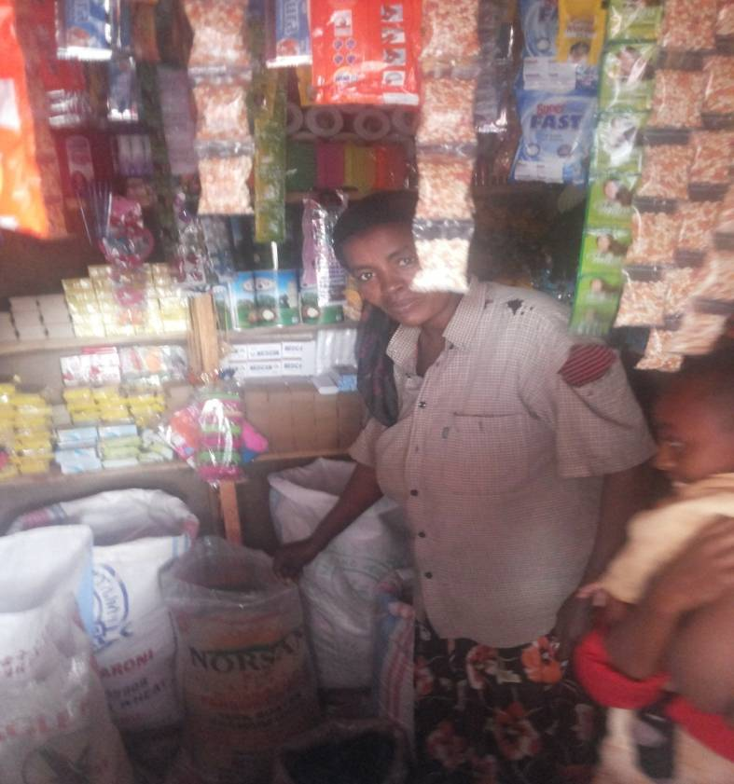
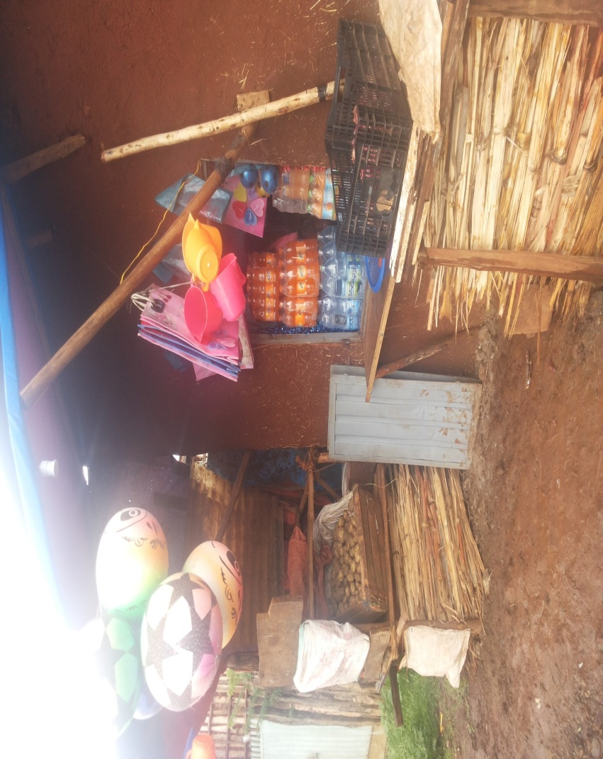

These days, she has fulfilled all her and her families’ basic needs and her life is completely changed for better. She has stable source of income and able to build assets, such as she bought house hold furniture like Television and decoder, arm chairs, bed and others. She has also built two class houses which rented for 200 ETB per month each. She now, sends her children to school properly. Given the changes and improvement of her livelihood, she said “My life has changed a lot in the previous 4 years due to MJDA’s project. In the future, with God’s help my plan is to buy a car and engage in large scale business, and live my life comfortably.”

3.4. Private-Public-Partnership
Mary Joy development association had been fully dependent on external donors funding until it celebrates its 10th year anniversary in 2005, however it used this moment as a turning point to make a strategic shift and launched the Private Public Partnership Program with a theme of “Ethiopians to Ethiopians Movement”. Since then, the organization has been designing and implementing the private public partnership interventions and strategies and able to mobilize the government, communities, the provide sector, the Ethiopian Diaspora and foreigner supporters of the organization to be part of the program for the good social cause. The broaden goal of the initiative is to up hold the society’s engagement in the poverty reduction effort in an organized manner. The program promotes “YES, WE CAN BRING CHANGE ON THE LIVES OF OUR VULNERABLE CHILDREN, WOMEN AND ELDERS” and practically bye-in the idea by the wider public and responses have been solicited.
Over the reporting period, MJDA able to mobilize nearly 36% of the total budget, this is in line with the strategic plan as well as mobilized the society from all walks of life. One of the greatest achievements of the year 2017 is the colorful inauguration of the Hawassa Elder Center, which is the legacy of government sectors, private sectors, individuals, small and large business men and women, Diaspora and the wider community.
Herein, volunteer artists, media professionals, writers, painters, models, volunteer architects, civil engineers, and consultants played marvelous roles in realizing the center.
MJDA mobilized wide range of the communities, private sectors, public sectors regardless of any variables to come together to alleviating the vulnerability of children and elders.
Table 4 accomplishment of Private-public partnership program component interventions vis-à-vis plan, 2017, MJDA
No. | Description of interventions | UOM | Annual physical plan | Accomplishment | %age | Remark
1 | Family sponsorship support for children | HVC | 1485 | 1718 | 116%
2 | Holiday lunch program for children | HVC | 1800 | 1699 | 94%
3 | conduct discussion with sponsored children and care givers on their educational attendance, performance and social issues | HVC | 2400 | 2468 | 103%
4 | Facilitate free scholarship for children and youth (covering costs related to copy and transport) | Youth | 50 | 10 | 20%
5 | Collection and distribute the donation materials to 2000 beneficiaries (1600 children & 400 elders) (transportation expenses) | person | 6500 | 6561 | 101% | The kind of materials distributed are cleaning materials detergent, casual clothes, household utensils, foam mattress , bed sheet, blanket
6 | Organize four days training for 90 sponsored children on life skills, self-assertiveness, public speaking and communication skills | person | 90 | 105 | 117%
7 | Sponsorship support for elders | Elder | 485 | 279 | 58%
8 | Organize elders inspiration and holiday lunch program | Person | 300 | 286 | 95%
9 | Sensitize different community groups for local resource mobilization through seminar, workshop, panel discussion, forum etc | session | 5 | 7 | 140% | 245 Artists, media professionals, private sectors, government sectors offices have participated on the discussions
10 | Aware the public through electronic media communication (TV and radio) and social medias | person | 20000 |  |  | Over 100,000 have been reached through MJDA face book, JTV, KANA, EBS, various FM radios
11 | Organize visiting & discussion programs with potential sponsors to get sponsorship support for children and elders | No | 131 | 450 | 344%
12 | Organize visiting & discussion programs with potential academic schools, vocational school and higher institutions | No | 14 | 16 | 114%
13 | IEC Material Production and Distribution to increase public awareness and mobilize local resources to address the needs of target children and elders like brochures, poster sticker | No | 3000 | 5000 | 167%
14 | Promotion of membership | No | 250 | 154 | 62%

3.5. Children empowerment and participation
Over the period, MJDA has implemented investment in children aiming to empowering children and enhance their participation in the matters that affect their lives. The project interventions focused on building the capacity of child led initiatives and children’s parliament in schools and out of school setting, government sectors and community structures. Moreover, the project enhance public awareness on investment in children issues, social accountability, children’s engagement on budget planning, performance review sessions, child rights and so on.
Table 1 accomplishment of investment in children program component interventions vis-à-vis plan, 2017, MJDA
No. | Description of interventions | UOM | Annual physical plan | Accomplishment | %age | Remark
1 | Conduct a five days training on budget advocacy and monitoring of budget and services for 60 representatives of child led initiatives, government sectors and community groups, and CRC committees | person | 60 | 85 | 142% | Male 40; Female 45
2 | Conduct a three days training on CRP, child participation, accountability and transparency for 30 CRG CSO staff members. | Person | 30 | 50 | 167 | Male 28; Female 22
3 | Technical and financial support to CRC committees for their effective engagement in investment in children and implementation activities 8*10,000 | No of CRC committee | 8 | 6 | 75%
4 | Conduct a three days training on child rights (including budget and services) monitoring using social accountability tools of the government (MoF, MoH) for 100 members of child led initiatives, government sectors and community groups | person | 100 | 163 | 163% | Male 93; Female 70
5 | Duplicate training materials and tools for training participants, and guiding materials for child networks | LS | 1 | 1 | 100%
6 | Financial support for child led groups to engage in budget processes, advocacy, and monitoring services in schools. | child led group | 8 | 20 | 250%
7 | Financial support for children's network to undertake quarterly meetings to share their achievements and experiences in child rights work | No of networks | 3 | 2 | 67%
8 | Document the achievements of children's network and share to child led groups and stakeholders | LS | 3 | 1 | 33%
10 | Provide financial support to social accountability groups to undertake monitoring of services in schools and undertake interface meetings with duty bearers. | No | 3 | 4 | 133%

4. Challenges
With all these achievements, MJDA has faced the following challenges:
- As the vehicles of Mary Joy are old and depreciated, over time the maintenance cost rose up which could pressurized the MJDA’s meager resources as well as became barriers to facilitate the organization’s tasks
- From program perspective due to the current donor shift of focus and resource scarcity, over time MJDA’s program interventions and diversification are getting declining

5. Appreciation and gratefulness
MJDA extends its gratefulness for its strategic partners and avails its highest assurance of consideration for their outstanding contributions and support.
 

